Synopsis on
Prediction of FOREX rates using a Hybrid System

By
Nathan D’Lima
Registration no: stfrancis45
PID no: M13207
Guide: Mr. Shamsuddin S. Khan

Academic Year: 2014 – 2015
Master of Engineering in Computer Engineering
St. Francis Institute of Technology
University of Mumbai
- Abstract
Currency exchange is the trading of one currency against another. Forecasting the foreign exchange rate is an uphill task. FOREX rates are influenced by many correlated economic, political and psychological factors. Like many economic time series, FOREX has its own trend, cycle and irregularity.
Many methods have been used to predict the future FOREX rates. Some of the common methods include statistical analysis, time series analysis, etc. Some of the modern methods used are fuzzy systems, neural networks, hybrid systems, etc. These methods suffer from the problem of accurately predicting the exchange rates with low accuracy and precision.
The objective is to predict single day exchange rates with higher accuracy and precision. By using two different methods, i.e. a Neural network and a Hybrid system, a more accurate and robust method can be developed. A Multilayer Perceptron (MLP) is used to predict the rise and fall of the FOREX market while an ANFIS system is used to predict the future rate.
- Introduction
Foreign Currency Exchange or Foreign Exchange is commonly known as FOREX. The foreign exchange market is the place where currencies are traded. The FOREX market is one of the most exciting, fast-paced markets around. Until recently, FOREX trading in the currency market had been the domain of large financial institutions, corporations, central banks, hedge funds and extremely wealthy individuals. The emergence of the internet has changed all of this, and now it is possible for average investors to buy and sell currencies easily with the click of a mouse through online brokerage accounts [1].
The foreign exchange market is a global decentralized marketplace that determines the relative values of different currencies. Unlike other markets, there is no centralized depository or exchange where transactions are conducted. Instead, these transactions are conducted by several market participants in several locations. It is rare that any two currencies will be identical to one another in value, and it’s also rare that any two currencies will maintain the same relative value for more than a short period of time. In FOREX, the exchange rate between two currencies constantly changes.
Currencies trade on an open market, just like stocks, bonds, computers, cars, and many other goods and services. A currency's value fluctuates as its supply and demand fluctuates, just like anything else. An increase in supply or a decrease in demand for a currency can cause the value of that currency to fall. A decrease in the supply or an increase in demand for a currency can cause the value of that currency to rise. A big benefit to FOREX trading is that you can buy or sell any currency pair, at any time subject to available liquidity. This also means that there really is no such thing as a "bear market," in the traditional sense. You can make (or lose) money when the market is trending up or down [2].
Problem Statement: The main drawback of current systems is the inability to provide high accuracy rates for future predicted values. A simple neural network gives very low accuracy. The objective is to predict future exchange rates using a Hybrid System that combines a Multilayer perceptron to predict the rise or fall of the market and an ANFIS model to predict the future rate with greater accuracy.
- Literature Survey
In [6], Christina and Masoud used three different methods for forecasting exchange rates. Currency exchange data US Dollar (USD) and British Sterling Pound (GBP), Euro (EUR) and Swiss Franc (CHF) between 3rd January 2012 and 1st March 2013 was used. The three methods used were Neural Networks (NN), Vector Singular Spectrum Analysis (VSSA) and Recurrent Singular Spectrum Analysis (RSSA). Root Mean Square Error (RMSE) and Direction Change (DC) were used as performance measures. The methods, however, gave an approximate 60% and 48% accuracy in the case of VSSA, RSSA and NN respectively.
In [5], Cwiok and Kordos proposed a new method in stock trading strategy. The approach uses neural networks to determine an optimal buy and sell time for stocks. Stock trading data from 1st January 1995 to 31st December 2004 was used as training set and data from 1st January 2005 to 1st January 2008 was used in training. This method uses three learning algorithms – Standard back propagation with momentum, modified back propagation and variable step search algorithm. Initial Gaussian data was transformed to a uniform distribution to reduce effect of outliers. The input parameters used were – Price range, simple moving average, rate of change, relative strength index, commodity channel index, stochastic oscillator, average true rate and candle formations. The time period of price range used was 1, 2 and 3 days while the time period for the remaining inputs were 6, 9, 14 and 21 days. The neural network consists of 2 hidden layers with each node having a tanh sigmoidal activation function. The output of the neural network is an optimal buy or sell signal for different stocks.
In [7], Kodogiannis and Lolis make use of a hybrid system to predict future rates between the currencies of US Dollar (USD) and British Sterling Pound (GBP). A dataset of 1000 daily rates from the end of 1997 to end of March 2000 was used. Five different methods used were – MLP with standard back propagation, RBF, Autoregressive Recurrent Neural Network (ARNN), Elman neural network and Adaptive Fuzzy Logic System (AFLS). MLP uses 5 inputs with 2 hidden layers and a standard back propagation algorithm. RBF network is trained using Orthogonal Least Squares (OLS) method since it can train the network quicker. ARNN has 2 hidden layers and a single output node. It allows recurrence only in the first hidden layer. Elman network has 4 input nodes, 1 output node and 2 hidden layers with 16 and 24 nodes respectively. Self-feedback is applied on the hidden layer with 16 nodes. AFLS is a hybrid neuro-fuzzy system. It has multiple inputs and multiple outputs. A new method called Balance of Area (BOA) is used for defuzzification. This defuzzification method gives a result very close to centroid method.
In [8], Kia, Fathian and Gholamian made use of along with Auto Regressive Integrated Moving Average (ARIMA). Simple linear ARIMA cannot be used to model financial data since financial series have high non-linearity, high noise and high complexity. To solve the non-linearity problem, Multilayer Perceptron (MLP) and Radial Basis Function (RBF) were used. The proposed model calculated the FOREX rate using ARIMA and the error of that was modeled by MLP. The remaining error was then given to a RBF network to further reduce the final error. The combination of MLP, RBF and ARIMA gives a better result as compared to each method individually. 3440 daily exchange rates from 1st August 2001 to 31st July 2010 were used. The days without data were padded with the average exchange rate value of the last three days. The neural network uses up to 7 days previous data for learning and predicting the rate for the next day.
Emad and Montazeri in [4] use an Interval Type 2 (IT2) Fuzzy Neural Network. The prediction of Euro (EUR) and Swiss Franc (CHF) is done against US Dollar (USD). This method makes use of a Karnik-Mendel type reducer for Fuzzy C-means clustering and a Multilayer Neural Network. The inputs to the model are closing price, simple moving average (%K) and exponential moving average (%D). The inputs are fuzzified and given as input to the Karnik-Mendel type reducer for fuzzy clustering. The input membership functions are interval type 2 fuzzy membership functions. They use a Gaussian membership function to define the value. The MLP neural network uses the input to predict the future currency rate. It consists of a single hidden layer with 20 neurons. A back-resilient algorithm is used for training the network. 50 epochs were used in the training of the neural network. The algorithm helps to train the neural network quicker. The rule base is a dynamic rule base that takes into account the number of input membership functions. In order to find the best number of clusters to be used and the number of rules, a test was made. The result of the test obtained 7 rules for EURUSD dataset while for the USDCHF dataset, 6 rules obtained the best result. Data between 1st April 2005 and 10th December 2012 was used as the dataset. Along with the proposed system (IT2FCMFNS), two other neuro-fuzzy methods (FLIT2FNS and T1FCMFNS) were compared. The proposed system was better than the other methods. The experimental results showed that the system could handle fluctuations with a high degree of accuracy.
Table 1 summarizes the various methods discussed above. It summarizes the currencies exchanged, method used, training samples and performance measures of each of the methods.
- Summary
Reference | Currencies | Method | Training Sample | Performance
[6] B. Christina, Y. Masoud | USDGBP  USDEUR  USDCHF | Neural Network  VSSA  RSSA | From 3rd January 2012 to 1st March 2013 | Basic RSSA – 60% accuracy  Neural Network – 48% accuracy  (SSA 67% better than NN)
[5] A. Cwiok, M. Kordos | (Stock Trading) | Standard BP with Momentum  Modified BP  Variable Step Search | From 1st January 1995 to 31st December 2004 | Provides optimal buy and sell signals
[7] V. Kodogiannis and A. Lolis | USDGBP | MLP with Standard BP  RBF  Autoregressive Recurrent Neural Networks  Elman Neural Network  AFLS with BOA | From end of 1997 to end of March 2000 |  | % Error | RMSE
 |  |  |  | MLP | 0.31 | 0.421
 |  |  |  | RBF | 0.2646 | 0.3905
 |  |  |  | ARNN | 0.2711 | 0.4021
 |  |  |  | Elman | 0.2683 | 0.4010
 |  |  |  | AFLS | 0.2514 | 0.3939
[8] A.N. Kia, M. Fathian and M.R. Gholamian | EURUSD | Single ARIMA  Single MLP  Single RBF  Hybrid Model (ARIMA+MLP+RBF) | From 1st August 2001 to 31st July 2010 |  | RMSE | D-stat
 |  |  |  | ARIMA | 0.0081 | 65%
 |  |  |  | MLP | 0.0076 | 67%
 |  |  |  | RBF | 0.0085 | 59%
 |  |  |  | Hybrid | 0.0068 | 71%
[4] Emad F, M.A. Montazeri | EURUSD  USDCHF | IT2FCMFNS  T1FCMFNS  FLIT2FNS | From 1st April 2005 to10th December 2012 |  | EURUSD | USDCHF
 |  |  |  | FLIT2FNS | 0.00613 | 0.00582
 |  |  |  | T1FCMFNS | 0.00172 | 0.00207
 |  |  |  | IT2FCMFNS | 0.00165 | 0.00101

- Proposed Solution
Two separate methods are used. The first method makes use of Stock market predictions. It uses MLPs to predict the rise and fall of the market. The same method will be applied to FOREX prediction. A Multilayer Perceptron network will be used with 4 inputs – Closing Price, Simple Moving Average, Rate of Change and Stochastic Oscillator, to predict the trend direction of the FOREX market. A supervised learning method is used in this case. Standard back propagation algorithm will be used to update the weights of the network. The model is described in Fig. 1.
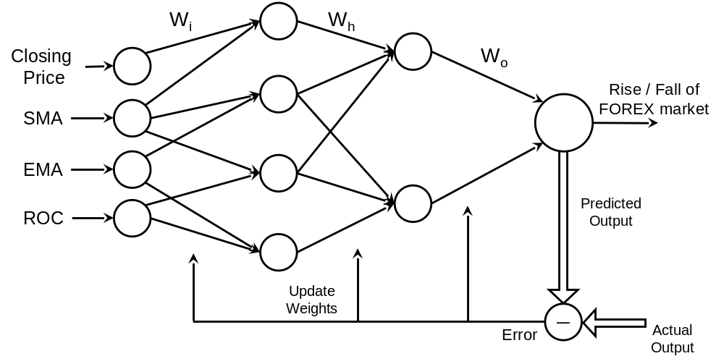

Fig. 1. MLP Neural Network with Back propagation
The second method will utilize a Neuro-Fuzzy Hybrid system to predict the future FOREX rate. Adaptive Neuro Fuzzy Inference System (ANFIS) will be used to implement this method. The ANFIS model will make use of 2 inputs – Closing price and moving average. The inputs will be fuzzified using a simple Gaussian membership function. A single output – the future closing price, will be given after Defuzzification.

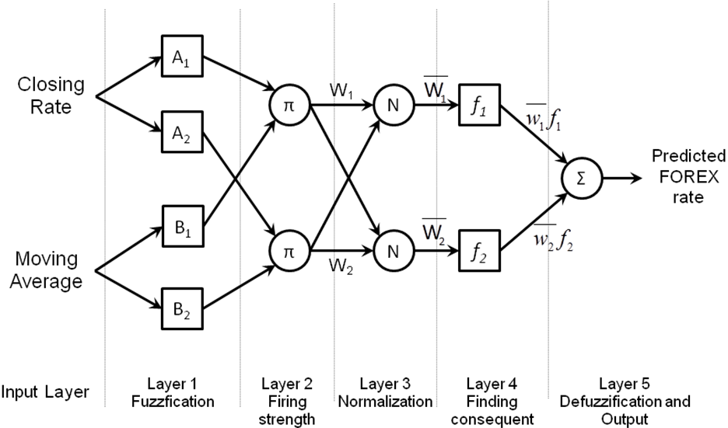
Fig. 2. ANFIS Architecture
Fig. 2 shows the architecture of the ANFIS model [9]. The 2 inputs are given to the first layer which is a fuzzification layer. The inputs are fuzzified using a Gaussian membership function given by (1).
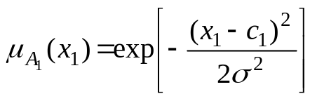
(1)
Layer 1 contains adaptive nodes which fuzzifies the inputs and gives it to the second layer. Each node in this layer is a fixed node labeled. This layer calculates the firing strength of the antecedents using T-norm or T-conorm operators as in (2). Here we obtain output of the ith node in the jth layer.
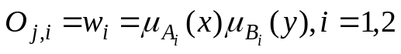
(2)
The output of this layer is then normalized by the third layer which is a fixed node labeled N. This layer normalizes the weights using (3). This is called the normalized firing strength. The i^{th} node calculates the ith rule’s firing strength to the sum of the firing strength of all the rules.
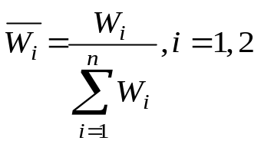
(3)
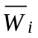
Where n is the number of nodes in the layer 2. is the normalized weight that is given to the adaptive node in layer 4. This layer calculates the firing strength of the consequents using the rule base. The output is dependent on the type of Fuzzy Inference System (FIS) being used, in this case a 2-input first order Sugeno FIS. The output of this layer is defined by the function shown in (4).
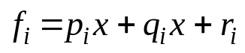
(4)
The final output is given by the node in layer 5. It computes the output as the summation of all the incoming signals. Since the weights are already normalized it calculates the sum of the product of all the input signals with their corresponding weights as shown in (5).
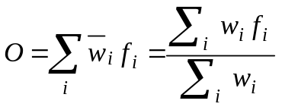
(5)
The error between the predicted output and actual output is checked. If some error exists then the premise parameters are updated using gradient descent method.
The ANFIS model predicts the future FOREX rate of the desired currency. The trend of the FOREX market is predicted by the MLP neural network. This predicted trend is useful in predicting the price as a rise in the market should be reflected by an increased FOREX rate and a fall will be reflected with a drop in the rate. Thus the combination of both methods will help to give a more accurate prediction.
- Resources & Implementation
The resources that will be required for the project are a computer running an operating system of Windows Vista or better. A memory of at least 100 GB with a RAM of 2GB is required. The data from 23rd October 1993 till date is collected in a csv (Comma Separated Value) file. The data sets will be obtained from oanda.com [3]. The data set consists of the date and its closing price. A total of more than 8000 entries are stored. From this set approximately 3 to 4 months data will be used in training phase while another set of 3 to 4 months data will be used in testing phase. The project will be implemented using MATLAB2013.
- Performance Analysis
The performance analysis will be done using the Root Mean Square Error (RMSE). The Error of the proposed system will be compared against the error of the already existing methods (as given in the literature survey). The error from the training and testing phase will be used to decide if additional data samples are required to improve the performance. Performance will also be measure in the time taken for the networks to learn and produce the desired output. If the output is not within the preset threshold, the data set will be increased.
This method will also be used to determine the number of hidden layers and the nodes required in each hidden layer. The model will be built with a random number of hidden layers and nodes in each layer. The RMSE will be calculated and based on the result the number of nodes may be increased or decreased to obtain the least possible RMSE value. The number of rules in the hybrid system will also be decided in the same way.
Schedule
The initial survey part will take up approximately 3 months. This time is required to get acquainted with the methods used in the past and the current methods that are used. During this time, a few weeks are needed to design the proposed system.
A beta version of the project will take approximately another 3 to 4 months. Following which a final version of the project will be ready. The beta version will be used to test the various modules, functions and will be used to fix any bugs or errors that may occur. This phase will be followed by the testing phase which will test if the output is within acceptable limits. A summary of the schedule is shown in the Table 1.
 | Aug ‘14 | Sep ‘14 | Oct ‘14 | Nov ‘14 |  | Dec ‘14 | Jan ‘15 | Feb ‘15 | Mar ‘15 | Apr ‘15 | May ‘15
Survey
Study of Past methods
Design of Proposed System
Initial Code
Beta Version
Training and Testing
Final version

- Potential Impact
There is a huge potential impact of the prediction of FOREX rates in society. It will benefit not only the traders but the individuals and the country as well. The prediction of the rates will allow traders, banks as well as investors to appropriately create a strategy that maximized the profits and minimizes the risk. Individuals can use the prediction to plan their future in a foreign country for example, students looking to pursue higher studies or individuals seeking employment, etc.
- References
- FOREX market, Available: http://www.investopedia.com/university/FOREXmarket/
- What is FOREX, Available: http://www.fxcm.com/markets/FOREX-basics/what-is-FOREX/
- Historical FOREX data, Available : http://www.oanda.com/currency/historical-rates/
- Emad F, M.A. Montazeri, “ Forecasting Foreign Exchange Rates Using an IT2 FCM based IT2 Neuro-Fuzzy System” in 21st Iranian Conference on Electrical Engineering (ICEE), 2013.
- A. Cwiok, M. Kordos, “A New Approach to Neural Network Based Stock Trading Strategy”, in Intelligent Data Engineering and Automated Learning - IDEAL 2011 Lecture Notes in Computer Science Volume 6936, 2011, pp 429-436.
- B. Christina, Y. Masoud, “Forecasting Exchange Rates: An Optimal Approach” in J Syst Sci Complex (2014) 27: 21–28.
- V. Kodogiannis and A. Lolis, "Prediction of foreign exchange rates by neural network and fuzzy system based techniques," in European Symposium on Artificial Neural Networks Bruges (Belgium), April 2001, pp. 245-250
- A.N. Kia, M. Fathian and M.R. Gholamian, “Using MLP and RBF Neural Networks to Improve the Prediction of Exchange Rate Time Series with ARIMA”, International Journal of Information and Electronics Engineering, Vol. 2, No. 4, 2012, pp. 543-546
- J.S.R. Jang, C.T. Sun and E. Mizutani, Neuro-Fuzzy and Soft Computing – A Computational Approach to Learning and Machine Intelligence, Prentice-Hall Inc., 1997.

